Goalball Junior Day
East Midlands, 30th May 2022
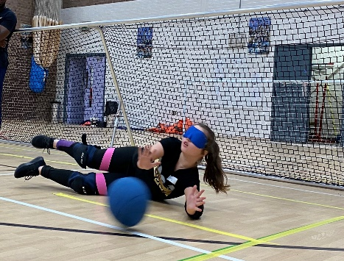
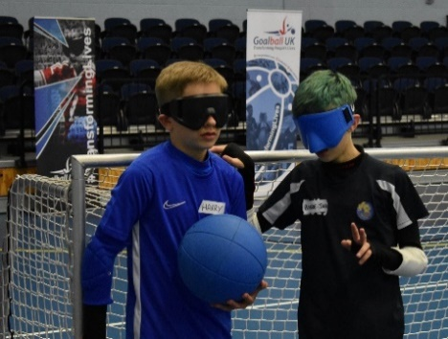
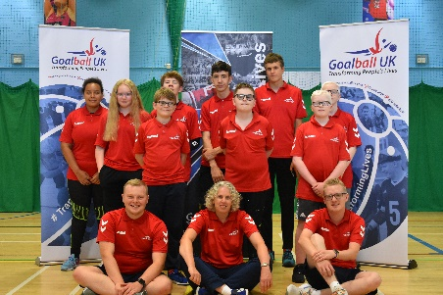
The event is open to young people aged 8-16 of any sight level, and to new or existing players.

Players will have the opportunity to develop their on-court skills through fun games and friendly matches, delivered to suit all abilities. Players will also have time to socialise through structured fun activities.

Date: Monday 30th May 2022
Time: 10am arrival, 3pm departure
Cost: £5 (includes a Goalball UK goodie bag), booking and pre-payment required.

Venue: Sutton Bonington Sports Centre, University of Nottingham - Sutton Bonington Campus, College Road, Sutton Bonington, LE12 5RB.

Parents, carers, and guardians are welcome to stay or drop the young person off. However, if so, the young person must be independent.

Booking: Please email stephen.newey@goalballuk.com to request a booking form, or use the following link: Booking Form - East Midlands

More Information
If you require any more information or have any questions, please contact Stephen Newey (Goalball UK) stephen.newey@goalballuk.com.

